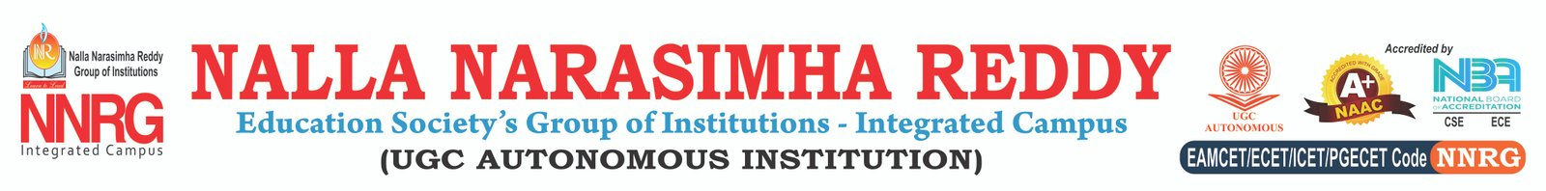
ABSTRACT
Inappropriate Comments Scanner
Authors: Adithya Singh [217Z1A6702], Chereddy Harini Reddy [217Z1A6713], Narala Hema Narendra Reddy [217Z1A6743]
Affiliation: Department of Computer Science and Engineering, Nalla Narasimha Reddy Group of Institutions
In today’s digital landscape, the prevalence of inappropriate and offensive comments poses significant challenges for maintaining safe online communities. The "Inappropriate Comments Scanner" is an automated solution designed to detect and flag inappropriate language in online user-generated content. Utilizing advanced natural language processing (NLP) techniques and machine learning algorithms, this tool can accurately identify a variety of harmful comments, including hate speech, abusive language, and discriminatory remarks. This project integrates with social media platforms, forums, and educational sites to facilitate real-time monitoring and moderation, ensuring a respectful and safe environment for users. The scanner provides customizable filters, allowing administrators to define specific criteria for content flagging. With a user-friendly interface and support for multiple languages, the Inappropriate Comments Scanner stands as a versatile solution for moderating online spaces effectively...
Keywords: Inappropriate Comments, Natural Language Processing, Machine Learning, Content Moderation, Online Safety, Real-time Detection, Offensive Language Filtering, Customizable Filters, Multi-language Support, Safe Online Communities.

